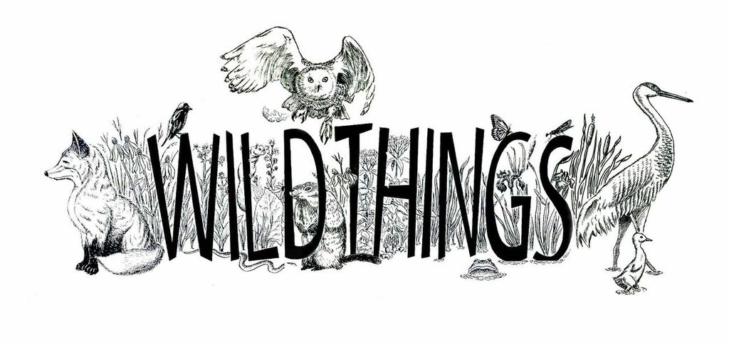
Wild Things 2015
“How to Reach and Connect With People”
Session 2L-11:15 to 12:00 p.m.

Take some time to understand the interests and skills of your fellow volunteers. Everyone is good at something (i.e. mapping, brush-pile building, community organizing, plant ID, bird ID, trail-building, photography, outreach). Connect people with shared interests and skills to each other, and help them obtain the resources they need to learn more. Allow others to help strategize restoration priorities and actions. It will empower the individual and in turn will make the volunteer group stronger. Daniel Suarez, Habitat 2030, Audubon-Chicago Region

Every movement begins with a kickoff. In order to engage new audiences of volunteers, it is essential to build and maintain momentum and enthusiasm for the movement. One great way to do this is by organizing a grand "kick-off" event. This can be essential in order to bring great minds together for a common goal, especially long term. Josh Coles, Friends of the Forest Preserves

Change behaviors, not minds. When getting volunteers or conducting community outreach, remember that your audience might not think your preserve is all that special, or care about the endangered species that lives on it. And that’s OK! What really matters is that they take actions to protect that preserve or that species. So, when recruiting volunteers and conducting community outreach, if you want to engage new people (those not already in your choir), consider using language that is more universal. Try emphasizing the benefits of exercise, enjoying sunshine, camaraderie or racking up volunteer hours, not just the conservation, environmental side. Rebeca Bell, Communications Director, Bluestem Communications
Lay the groundwork for successful experiences for every volunteer, from Cub Scouts to corporations: When engaging volunteers, give them all the basic information they need to arrive ready for a productive and fulfilling experience. Any surprises can then be good ones. Information to include: Name of group sponsoring the event, date, beginning and ending times, what the group will be doing (brush cutting, seed collecting, etc.), ages that can be involved, location of event, directions to event and helpful landmarks, what to bring (work gloves, loppers, etc.), what will be provided (tools, refreshments, etc.), what to wear, how to RSVP if necessary, contact phone number on event day. Sam Oliver, Citizens for Conservation
Understand how the public at large views your site. It might be very different than the way you do. For instance, if years ago your park or preserve was a noted gang hangout, that’s a reputation that can stick around for decades. Your outreach should address community concerns as much as environmental ones…Chris Weber, Friends of the Forest Preserves

Sing your praises. Think about ways to show off your volunteers to the community. Newspapers love community and nature photos. Send them pictures and stories about your workdays. Most local news has an online, do-it-yourself posting opportunity. Try it. Facebook? Twitter? Volunteer to do a presentation at your local library. Let the community get to know you and what you do. Pat Hayes, Orland Grassland Volunteer

